YuYu Chen

*Computer Engineering Department, College of Engineering*

*San Jose State University, San Jose, CA 95192*

*E-mail: yuyu.chen@sjsu.edu*

[1]

Embedded Wireless Architecture Implementation with LPCXpresso1769 module

*Abstract*— This lab report’s objective is to document the design and implementation of several wireless communication between two embedded systems modules. The first part of the report will detail landline communication and wireless communication between two embedded systems using a standard RF module. The second part of the report will detail the use of a state-of-the-art LorA module communication between two embedded system modules.

# INTRODUCTION

The first objective for two embedded system modules (node $N_{i}$ and node $N_{j}$) to communicate with each other is to establish synchronization between the two nodes. The technique used to establish synchronization is the Linear Invariant Synchronization Algorithm (L.I.S.A). L.I.S.A algorithm allows the user to recover the payload even when there are corrupted bits or timing error during synchronization. The payload is scrambled before transmission by node $N_{i}$ and descrambled by node $N_{j}$ when receiving the payload. The embedded system module used is LPC1769 microcontroller.

The report will begin with detailed descriptions of the methodology used, such as the objective and details. The next section will describe the implementation with the software. The last part of the report will be Testing and Verification, along with conclusion, reference, and appendix.

# Methodology

This section includes objectives of the lab, hardware design of the project in schematics, system setup in block diagrams, and layout of the prototyping board.

*A: Objectives*

The first objective of the lab was to establish synchronization between node $N_{i}$ and node $N_{j}$ using L.I.S.A algorithm. The next step was to write firmware drivers for the embedded system. Scrambling and descrambling algorithm is also used to reduce long sequences of “0”s and “1”s during wireless transmission.

1. Implement L.I.S.A algorithm in C to establish synchronization. Able to recover payload based on given confidence level.
2. Implement firmware drivers for LPC1769 to transmit and receive payload.
3. Implement Scrambling and descrambling algorithm.
4. Establish landline communication between node $N_{i}$ and node $N_{j}$.
5. Establish wireless communication between node $N_{i}$ and node $N_{j}$.

The second objective is use LorA module …….

1. Asdf
2. Ghjkl
3. Qwer

*B: Design*

This section shows the layout of the prototyping board, system setup in block diagrams, and design schematics in detail. To connect the hardware components onto the wire wrapping board, soldering and wire wrapping were needed to hold the components firmly onto the board.

Hardware Design:

Two embedded boards were designed per node. One board consists of the microcontroller and two RJ45 jacks. The other board consists of one 433MHz ASK RX and TX pair and three RJ45 jacks. A cat5 ethernet cable is used connect the two boards together or with another embedded board.

 Figure 1: Wire wrapping board layout with console

The RJ45 jack on the top-right of Figure 1 is used to connect to the RF board, providing $V_{CC}$ (from power supply), ground, TX (P0.2), and RX (P0.3). The other RJ45 jack on the bottom-right of Figure 1 is used to connect to node $N_{j}$, connecting ground, TX (P0.2), and RX (P0.3) for inter-process communication.

Figure 2: CPU module schematic

The pins chosen for TX and RX are J6-21 and J6-22, respectively. The pin assignments are shown in Table 1.

|  |  |  |
| --- | --- | --- |
| Pin Number | Description | Note |
| J6-21 | P0.2,  Tx, Output | GPIO  Transmitter |
| J6-22 | P0.3,  Rx, Input | GPIO  Receiver |
| J6-2 | Power |  |
| J6-1 | Ground |  |

Table 1: Pin Assignments for Embedded board

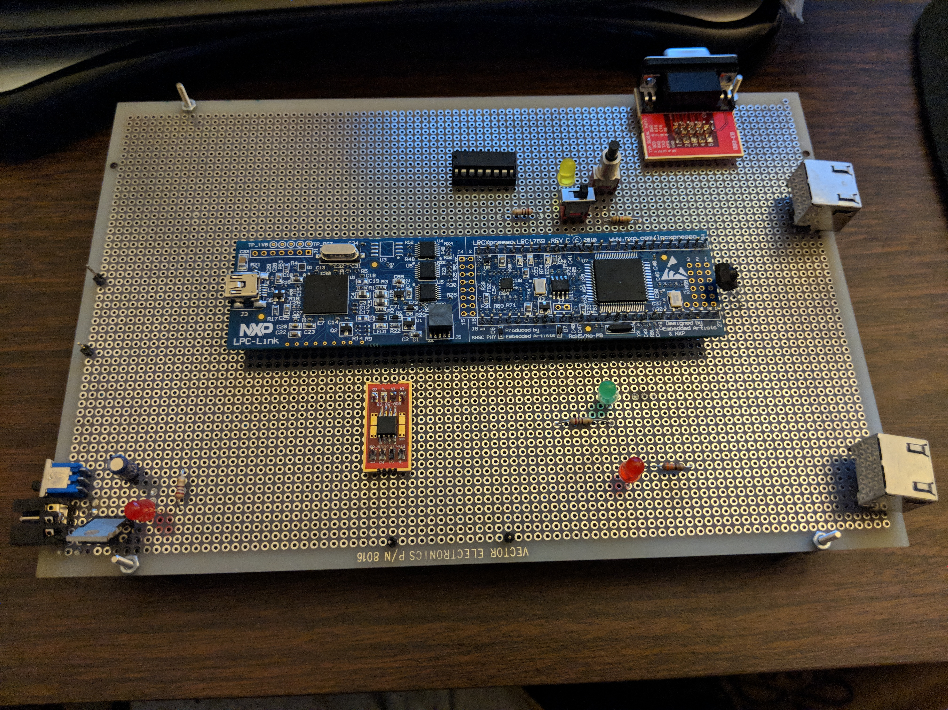

Figure 3: Layout of embedded board

The RF board is powered by 5V from the embedded board from one of the pins of the RJ45 jack. The switch on the RF board allows the user to only power one RF module at a time to reduce noise interference. The TX from the RJ45 jack goes to the Data port of the TX module, while the RX from the RJ45 jack goes to the Data port on the RX module. All modules on the device are connected to common ground. LEDs are added on to the RF board to let the user know which module is powered on when toggling the switch. The other LED is connected to the Data port of the RX module to visualize data being received.



Figure 4: RF board schematic

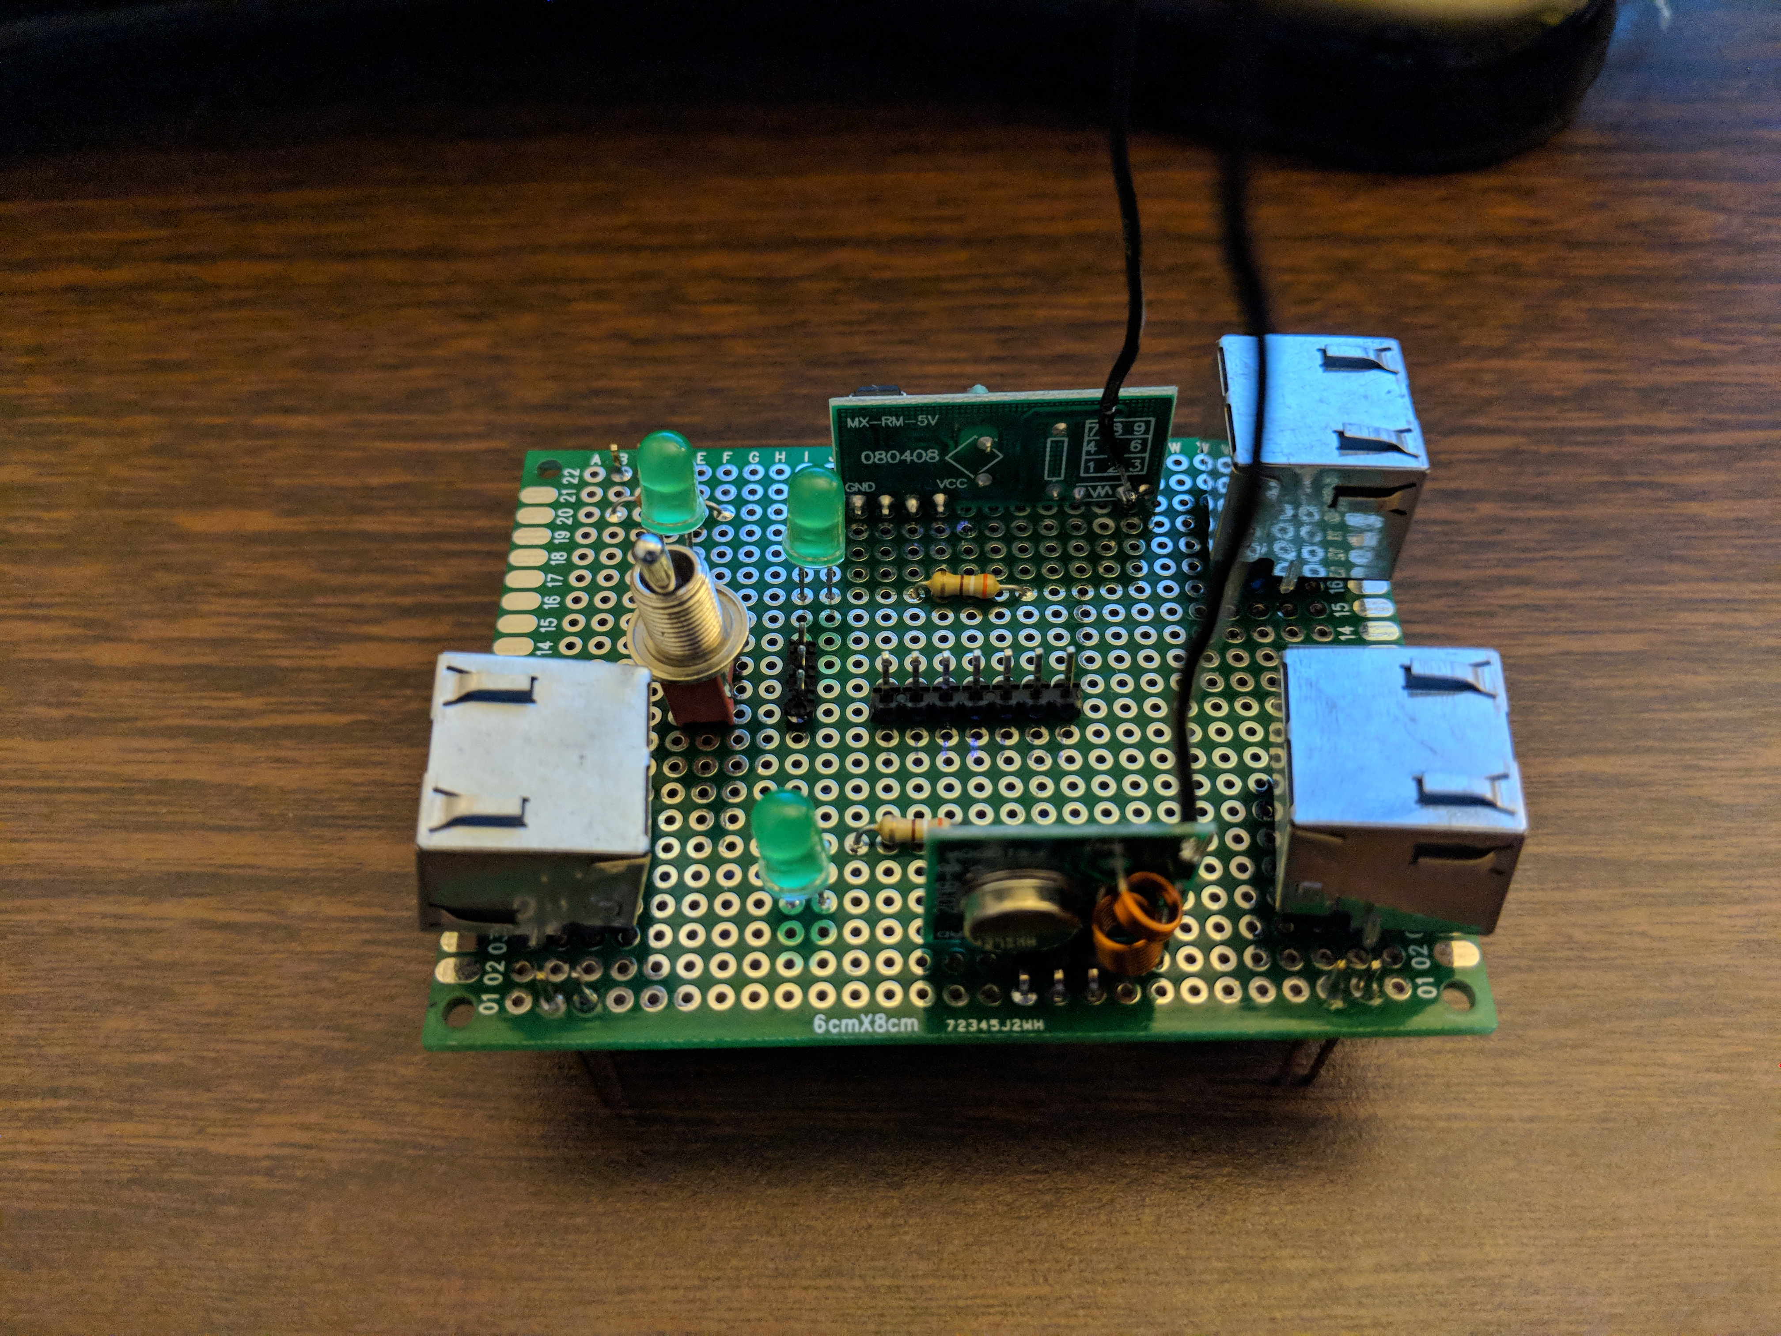

Figure 5: Layout of RF board

Software design:

L.I.S.A algorithm is used to sync and recover payload for two nodes communicating. L.I.S.A algorithm’s synchronization consists of alternating 4-bit patterns header of “1010” or 0xA and “0101” or 0x5. The other 4-bits consist of linear increment from 0x0 to 0xF. For example: 0xA0, 0xA1, 0xA2, …, 0xAF, 0x50, 0x51, …, 0x5F. Therefore, there will be a total of 32-bytes for the synchronization field. Using linear increment also allows the user to recover the starting point of payload. Alternating “0”s and “1”s are used to improve timing. Confidence level can be set by the user to match *n* number of bits for the data transmitted to be valid.

Implementing multiple drivers for the microcontroller is needed for both nodes to communicate. GPIO is used to transmit data by toggling the pin to output 3.3V or 0V depending on data being sent. GPIO is also used to receive incoming data by reading the pin. GPIO interrupt is also used to tell the receiver node to start sampling incoming data. A timer is also implemented to sample and transmit at a certain rate (highest rate achieved was 1Kbps). Therefore, both transmitter and receiver have to its timer set to the same rate to receive valid data.

Scrambler and descrambler is implemented in order to remove long sequences of “0”s and “1”s to improve timing and reduce jitter. The payload is scrambled before being transmitted and payload is descrambled on the receiver node. The user can input any order that is an odd number, such as 3, 5, 7, 9, etc. The higher the order the higher the polynomial, which increase its pseudo-randomness. Data is fed into delay units which delays it for one clock cycle. Depending on the order, outputs of the delay are XORed together and with the input to produce an output. At the receiver end, the descrambling is performed by subtracting the same sequence.



Figure 6: LISA algorithm field



Figure 7: Scrambler/Descrambler 5th Order Design

# Implementation

The implementation section interfaces the hardware module with firmware and software. The software implementation is done through MCUXpresso v10.0.2_411 IDE. The IDE allow the user to write C code to program their LPCXpresso1769 microcontroller module.

Two separate arrays with predefined data are created, one containing the L.I.S.A sync and the other is payload. After scrambling the payload, the two arrays are combined before being sent on the TX pin. A delay or a periodic timer can be used to send the data at a certain rate.

The receiver is implemented by first enabling GPIO interrupt on the receiver pin. The receiver pin will start sampling data at a certain rate based on the timer setting once it detects a rising or falling edge. After detecting an edge, the interrupt is disabled. Once sampled and storing in an array, the L.I.S.A algorithm reads the array to recover the payload. The L.I.S.A algorithm will iterate through the array until it matches the confidence level the user input at the beginning of the program. Once it matches the user’s confidence level, L.I.S.A algorithm will jump to the location of the starting payload. Before the payload is decode, the payload is first descrambled. The descrambled payload is then turned into ASCII character, so the user can read the payload.

Algorithm to TX and RX data:

1. Create sync field of 32 bytes consisting of 16 “0101xxxx” and 16 “1010xxx” patterns. Create payload array consisting of *n* amounts of bits that is divisible by 8.
2. TX: Scramble payload and combine with sync field. Transmit data using pin P0.2 with a periodic timer. After transmission, stop periodic timer.
3. RX: Enable GPIO interrupt and wait for rising or falling edge. After edge detection, disable interrupt and sample on RX pin P0.3 using a periodic timer. After data is received, stop the periodic timer.
4. Feed sampled data into L.I.S.A algorithm to locate starting position of payload.
5. Descramble payload and decode payload into human-readable format.



Figure 8: Flowchart for TX/RX algorithm

Pseudo Code:

Init_pins();

Init_timer();

Enable_timer_IRQ();

Enable_Eint3_IRQ();

Set_confidence_level();

Set_scramble_descramble_nth_order();

For TX:

Scramble();

Combine_sync_payload();

Start_timer();

Send_data();

// when done

Stop_timer();

Return success;

For RX:

Enable_interrupt();

If interrupt_triggered:

Disable_interrupt();

Start_timer();

Sample_rx();

// when done

Stop_timer();

Match_and_get_payload();

Descramble();

Decode_payload();

Return success;

# Testing and verification

L.I.S.A algorithm is tested by first implementing it on a laptop before porting it over to LPC1769. The program read a text file that is 1Kbytes with sync and payload. It would detect the sync field based on the given confidence level.

Drivers for LPC1769 are tested along the way of implementing. A logic analyzer is a useful tool for debugging embedded systems as the user can visualize waveform output, as well as timing information.

Scrambler and descrambler are tested by first implementing it on a laptop before porting it over to LPC1769. An array can be passed into the functions to scramble or descramble. The output of the scrambler will go into the descrambler and the descrambler should be the same as the input of the scrambler.

Landline testing is done first before doing wireless testing to test correct algorithm and bit rate. Different confidence level is tested as inputs to see how much data is corrupted or to see how fast data can be transmitted. Landline testing is done by connecting two embedded boards (nodes) together with a cat5 ethernet cable via RJ45 jacks.

Wireless testing is done after validating correct reception from the transmitter via landline testing. No data was received wirelessly between the two nodes when their antennas were both curled. The antennas had to be straightened out to receive data between the two nodes.

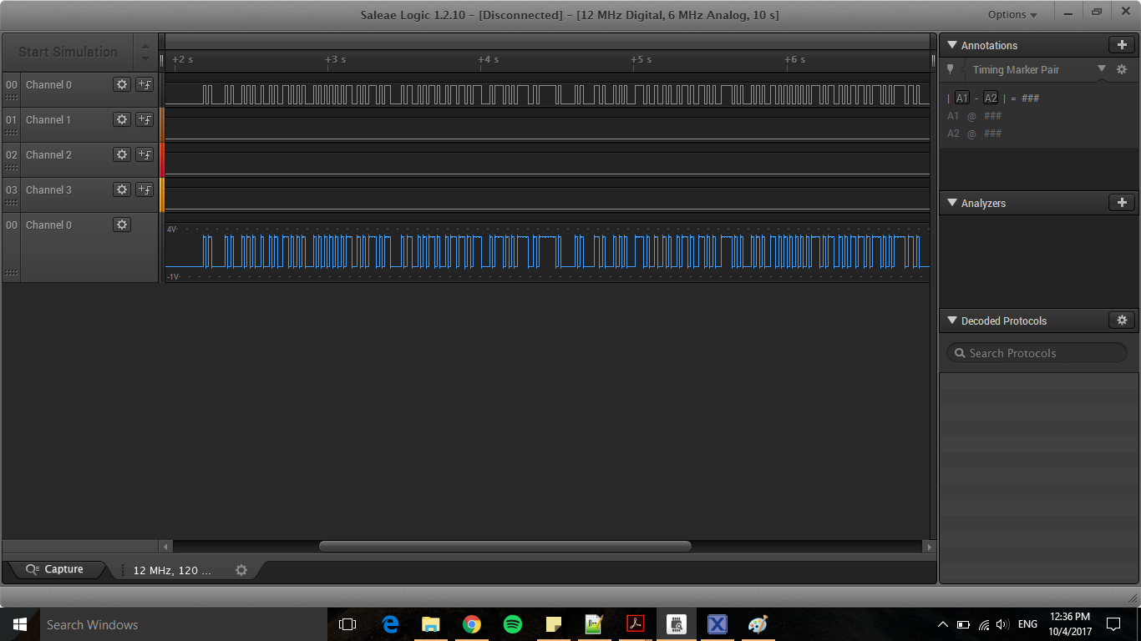

Figure 9: Logic analyzer waveform of data being transmitted on TX pin

# Conclusion

The objectives of the lab to implement wireless capabilities on LPCXpresso1769 microcontroller were satisfied by being able to send and receive data wirelessly using 433MHz TX/RX RF modules. Sending and receiving had to start at the same time or else it would not work. The interrupt on the receiver node also kept triggering because of random noise. Only one transmitter can be powered on or else the receiver will receive noise from other transmitter node, which will cause data corruption on the receiver node.

# References

[1] NXP Semiconductors, LPCXpresso1769 datasheet.

# Appendix

**Appendix A: Source Code**

**Source Code for Lab1.c**

/*

===============================================================================

Name : Lab1.c

Author : $YuYu Chen

Version :

Copyright : $(copyright)

Description : Lab 1 for CMPE245, Demoed, RX/TX, LISA, De/Scrambler, RF

TODO: implement timer1 peripheral for delay function, timer0 used for interrupt driven timer

===============================================================================

*/

#ifdef __USE_CMSIS

#include "LPC17xx.h"

#endif

#include <cr_section_macros.h>

#include <stdio.h>

#include <stdbool.h>

#include <stdint.h>

#include <string.h>

#define DEBUG 0

#define POLL_RX 0

#define POLL_TX 0

#define PAYLOAD_SIZE 88

#define SYNC_SIZE 256

#define RX_BUFFER_SIZE 1024

#define PAYLOAD_BUFFER_SIZE 256

// firmware

void start_timer(void);

bool enable_timer(uint32_t ms_delay);

void delayMs(uint32_t ms_delay);

void enable_interrupt(void);

void disable_interrupt(void);

// LISA

void decode_payload(void);

void set_confidence(void);

bool match_and_get_payload(void); // LISA algorithm

int sync(int p);

// scrambler/descrambler

void set_scramble_scramble_nth_order(void);

void scramble(int *payload);

void descramble(int *payload);

int syncdata[SYNC_SIZE] = {

1,0,1,0,0,0,0,0, //A prefix

1,0,1,0,0,0,0,1, //0xA1

1,0,1,0,0,0,1,0, //0xA2

1,0,1,0,0,0,1,1, //0xA3

1,0,1,0,0,1,0,0, //0xA4

1,0,1,0,0,1,0,1, //0xA5

1,0,1,0,0,1,1,0, //0xA6

1,0,1,0,0,1,1,1, //0xA7

1,0,1,0,1,0,0,0, //0xA8

1,0,1,0,1,0,0,1, //0xA9

1,0,1,0,1,0,1,0, //0xAA

1,0,1,0,1,0,1,1, //0xAB

1,0,1,0,1,1,0,0, //0xAC

1,0,1,0,1,1,0,1, //0xAD

1,0,1,0,1,1,1,0, //0xAE

1,0,1,0,1,1,1,1, //0xAF

0,1,0,1,0,0,0,0, //5 prefix

0,1,0,1,0,0,0,1, //0x51

0,1,0,1,0,0,1,0, //0x52

0,1,0,1,0,0,1,1, //0x53

0,1,0,1,0,1,0,0, //0x54

0,1,0,1,0,1,0,1, //0x55

0,1,0,1,0,1,1,0, //0x56

0,1,0,1,0,1,1,1, //0x57

0,1,0,1,1,0,0,0, //0x58

0,1,0,1,1,0,0,1, //0x59

0,1,0,1,1,0,1,0, //0x5A

0,1,0,1,1,0,1,1, //0x5B

0,1,0,1,1,1,0,0, //0x5C

0,1,0,1,1,1,0,1, //0x5D

0,1,0,1,1,1,1,0, //0x5E

0,1,0,1,1,1,1,1 //0x5F

};

int payload[PAYLOAD_SIZE] =

{

0,1,1,0,1,0,0,0, // h

0,1,1,0,0,1,0,1, // e

0,1,1,0,1,1,0,0, // l

0,1,1,0,1,1,0,0, // l

0,1,1,0,1,1,1,1, // o

0,0,1,0,0,0,0,0, // _

0,1,1,1,0,1,1,1, // w

0,1,1,0,1,1,1,1, // o

0,1,1,1,0,0,1,0, // r

0,1,1,0,1,1,0,0, // l

0,1,1,0,0,1,0,0, // d

};

int rx_buffer[RX_BUFFER_SIZE] = {0};

int payload_buffer[PAYLOAD_BUFFER_SIZE] = {0};

char decoded_payload[PAYLOAD_BUFFER_SIZE] = {'\0'};

int message_to_send[SYNC_SIZE + PAYLOAD_SIZE] = {0};

static uint8_t confidence = 0;

static int jump =0;

static int prev_jump =0;

volatile bool intr_triggered = false;

volatile bool rx_busy = false;

static int rx_buffer_index = 0;

volatile bool tx_busy = false;

static int tx_buffer_index = 0;

// scrambler

static uint8_t delay_nth_first[PAYLOAD_SIZE] = {0};

static uint8_t delay_nth_second[PAYLOAD_SIZE] = {0};

static int scramble_out[PAYLOAD_SIZE] = {0};

static int descramble_out[PAYLOAD_SIZE] = {0};

static int order = 0;

bool init_pins(void)

{

LPC_PINCON->PINSEL4 &= ~(3 << 12); // pin mux set to GPIO Port 2.6

LPC_GPIO2->FIODIR |= (1 << 6); // set GPIO Port 2.6 external LED as output

LPC_PINCON->PINSEL4 &= ~(3 << 14); // pin mux set to GPIO Port 2.7

LPC_GPIO2->FIODIR &= ~(1 << 7); // set GPIO Port 2.7 on external switch as input

LPC_PINCON->PINSEL0 &= ~(3 << 4); // pin mux set to GPIO Port 0.2

LPC_GPIO0->FIODIR |= (1 << 2); // set GPIO Port 0.2 as TX

LPC_PINCON->PINSEL0 &= ~(3 << 6); // pin mux set to GPIO Port 0.3

LPC_GPIO0->FIODIR &= ~(1 << 3); // set GPIO Port 0.3 RX

// enable_interrupt();

disable_interrupt();

return true;

}

void EINT3_IRQHandler(void)

{

if((LPC_GPIOINT->IO0IntStatR & (1 << 3)) || LPC_GPIOINT->IO0IntStatF & (1 << 3))

{

intr_triggered = true;

}

// Clear the status register of interrupt on P0.3

LPC_GPIOINT->IO0IntClr |= (1 << 3);

}

void enable_interrupt(void)

{

LPC_GPIOINT->IO0IntEnR |= (1 << 3); // rising edge of P0.3

LPC_GPIOINT->IO0IntEnF |= (1 << 3); // falling edge of P0.3

}

void disable_interrupt(void)

{

LPC_GPIOINT->IO0IntEnR = 0x0; // disable rising edge

LPC_GPIOINT->IO0IntEnF = 0x0; // disable falling edge

}

bool init_timer(void)

{

LPC_SC->PCONP |= (1 << 1); // Power up timer0

// LPC_SC->PCLKSEL0 &= ~(3 << 2);

// LPC_SC->PCLKSEL0 |= (1 << 2); // PCLK_peripheral = CCLK

LPC_TIM0->PR = (SystemCoreClock / 4000) -1;

LPC_TIM0->TCR = (0 << 0); // Initially disable counting

return true;

}

// polling, need to change to timer1

bool tx_data(int *sync, int *data)

{

int i;

int message_to_send[SYNC_SIZE + PAYLOAD_SIZE] = {0};

bool success = false;

int success_count = 0;

scramble(data);

// Message to Send out of TX

for(i=0; i < SYNC_SIZE+ PAYLOAD_SIZE; i++)

{

message_to_send[i] = sync[i];

}

for(i = SYNC_SIZE; i < SYNC_SIZE + PAYLOAD_SIZE; i++)

{

message_to_send[i] = scramble_out[i-SYNC_SIZE];

}

if(LPC_GPIO2->FIOPIN & (1 << 7))

{

LPC_GPIO2->FIOSET = (1 << 6);

for(int i=0; i < SYNC_SIZE + PAYLOAD_SIZE; i++)

{

if(message_to_send[i] == 1)

{

LPC_GPIO0->FIOSET = (1 << 2);

success_count++;

}

else if(message_to_send[i] == 0)

{

LPC_GPIO0->FIOCLR = (1 << 2);

success_count++;

}

delayMs(10);

}

if (success_count == SYNC_SIZE+PAYLOAD_SIZE)

{

success = true;

// enable_interrupt();

}

}

else

{

LPC_GPIO2->FIOCLR = (1 << 6);

}

return success;

}

// interrupt driven based on timer interrupt

bool tx_data_ir(int *sync, int *data)

{

int i;

bool success = false;

int success_count = 0;

scramble(data);

// Message to Send out of TX

for(i=0; i < SYNC_SIZE+ PAYLOAD_SIZE; i++)

{

message_to_send[i] = sync[i];

}

for(i = SYNC_SIZE; i < SYNC_SIZE + PAYLOAD_SIZE; i++)

{

message_to_send[i] = scramble_out[i-SYNC_SIZE];

}

start_timer();

tx_busy = true;

printf("busy: %d\r\n", tx_busy);

while(tx_busy)

{

// wait for it to finish, let interrupt do the job

LPC_GPIO2->FIOSET = (1 << 6);

}

LPC_TIM0->TCR = (0 << 0); // stop timer

LPC_GPIO2->FIOCLR = (1 << 6);

tx_buffer_index = 0;

success = true;

return success;

}

// polling rx with delay

bool rx_data(int *buffer)

{

bool success = false;

enable_interrupt();

uint32_t i=1;

// edge detected

if(intr_triggered)

{

puts("disabling");

disable_interrupt();

intr_triggered = false;

buffer[0] = 1; // edge detected? counts as 1 bit?

puts("1");

// poll rest of data after rising edge

while(i < SYNC_SIZE+PAYLOAD_SIZE)

{

if(LPC_GPIO0->FIOPIN & (1 << 3))

{

buffer[i % RX_BUFFER_SIZE] = 1;

i++;

}

else

{

buffer[i % RX_BUFFER_SIZE] = 0;

i++;

}

delayMs(10);

}

// puts("");

// printf("i: %d\r\n", i);

success = match_and_get_payload();

if(success)

{

decode_payload();

}

}

return success;

}

// interrupt driven based on timer

bool rx_data_ir(int *buffer)

{

bool success = false;

enable_interrupt();

// edge detected

if(intr_triggered)

{

puts("disabling");

disable_interrupt();

intr_triggered = false;

buffer[0] = 1; // edge detected? counts as 1 bit?

start_timer();

rx_busy = true;

printf("busy: %d\r\n", rx_busy);

while(rx_busy)

{

// wait for it to finish, let interrupt do the job

}

LPC_TIM0->TCR = (0 << 0); // stop timer

// puts("");

// printf("i: %d\r\n", rx_buffer_index);

rx_buffer_index = 0;

success = match_and_get_payload();

if(success)

{

decode_payload();

}

}

return success;

}

void set_confidence(void)

{

printf("Please enter a confidence level between 1 and 32\n");

printf("A 1 would lead to a 3%% confidence and 32 would lead to a 100%% confidence\n");

scanf("%d", &confidence);

}

int sync(int p)

{

// look only for 0x5? or 0xA? pattern

if((rx_buffer[p] == rx_buffer[p + 2] && rx_buffer[p + 1] == rx_buffer[p + 3]) &&

(rx_buffer[p] != rx_buffer[p+1] && rx_buffer[p] != rx_buffer[p+3] &&

rx_buffer[p+2] != rx_buffer[p+1] && rx_buffer[p+2] != rx_buffer[p+3]))

{

jump = 8 * rx_buffer[p + 4] + 4 * rx_buffer[p + 5] +

2 * rx_buffer[p + 6] + 1 * rx_buffer[p + 7];

#if DEBUG

printf("jump: %d\r\n", jump);

#endif

// Any sequence of 0x5? or 0xA?

if((jump == (prev_jump + 1)) || (jump == (prev_jump - 15)) || (jump == 0))

{

prev_jump = jump;

#if DEBUG

printf("########prev jump: %d\r\n", prev_jump);

#endif

return 1;

}

else

return 0;

}

else

return 0;

}

bool match_and_get_payload(void)

{

bool success = false;

int position = 0;

int limit = 768-(8*(confidence));

int i = 0;

for(i = 0; i < limit; i++)

{

int match = 0, locate = 0;

position = i;

#if DEBUG

printf("outer position: %d\r\n",position);

#endif

while(match != confidence && position < limit)

{

locate = sync(position);

if(locate == 0)

{

break;

}

match = match + locate;

position = position + 8;

#if DEBUG

printf("inner position: %d\r\n", position);

#endif

}

if(match == confidence)

{

success = true;

break;

}

}

if(success)

{

position = position - 8;

int location = rx_buffer[position + 4] * 8 + rx_buffer[position + 5] * 4 +

rx_buffer[position + 6] * 2 + rx_buffer[position + 7];

if(rx_buffer[position] == 0)

{

printf("You are at location 0x5%x\r\n", location);

location = 128 - (8 * location);

}

if(rx_buffer[position] == 1)

{

printf("You are at location 0xA%x\r\n", location);

location = 256 - (8 * location);

}

int index = position + location;

printf("location: %d position: %d index: %d\r\n", location, position, index);

i=0;

for(int p = index; p < index + PAYLOAD_SIZE; p++)

{

payload_buffer[i] = rx_buffer[p];

i++;

}

}

else

{

puts("No match found");

}

return success;

}

void decode_payload(void)

{

uint8_t bits = 0;

int i;

descramble(payload_buffer);

for(i = 0; i < SYNC_SIZE+PAYLOAD_SIZE; i++) //PAYLOAD_SIZE

{

if(i != 0 && i%8 == 0)

{

int index = i/8 - 1;

decoded_payload[index] = ((char)bits);

bits = 0;

}

else

{

bits = bits <<= 1;

bits = bits | descramble_out[i]; // payload_buffer

}

}

printf("payload: %s\r\n", decoded_payload);

puts("");

}

void TIMER0_IRQHandler(void)

{

if ( LPC_TIM0->IR & (0x1<<0) ) // Check MR0 interrupt flag

{

LPC_TIM0->IR = 0xff;

}

// printf("tick\r\n");

// LPC_GPIO0->FIOPIN ^= (1 << 2);

if(tx_busy)

{

if(message_to_send[tx_buffer_index] == 1)

{

LPC_GPIO0->FIOSET = (1 << 2);

tx_buffer_index++;

}

else if(message_to_send[tx_buffer_index] == 0)

{

LPC_GPIO0->FIOCLR = (1 << 2);

tx_buffer_index++;

}

if(tx_buffer_index == SYNC_SIZE +PAYLOAD_SIZE)

{

tx_busy = false;

}

}

if(rx_busy)

{

if(LPC_GPIO0->FIOPIN & (1 << 3))

{

// printf("1");

rx_buffer[rx_buffer_index % RX_BUFFER_SIZE] = 1;

rx_buffer_index++;

}

else

{

// printf("0");

rx_buffer[rx_buffer_index % RX_BUFFER_SIZE] = 0;

rx_buffer_index++;

}

if(rx_buffer_index == SYNC_SIZE + PAYLOAD_SIZE)

{

rx_busy = false;

}

}

}

bool enable_timer(uint32_t ms_delay)

{

// LPC_TIM0->MCR |= (1<<0) | (1<<1); // enable interrupt, reset tick on MR0

LPC_TIM0->TCR = (1 << 1); // reset timer

LPC_TIM0->PR = 0x00; // set prescaler to zero

LPC_TIM0->MR0 = (ms_delay * (SystemCoreClock/4000)) -1;

LPC_TIM0->IR = 0xff; // reset all interrrupts

// LPC_TIM0->TCR = 1; // start timer

return true;

}

void start_timer(void)

{

LPC_TIM0->MCR |= (1<<0) | (1<<1) | (0<<2); // enable interrupt, reset tick on MR0, do not stop on MR0

LPC_TIM0->TCR = 1; // start timer

}

void delayMs(uint32_t ms_delay)

{

LPC_TIM0->TCR = (1 << 1); // reset timer

LPC_TIM0->PR = 0x00; // set prescaler to zero

LPC_TIM0->MR0 = (ms_delay * (SystemCoreClock/4000)) -1;

LPC_TIM0->IR = 0xff; // reset all interrrupts

LPC_TIM0->MCR = (1 << 2); // stop timer on match

LPC_TIM0->TCR = 1; // start timer

while(LPC_TIM0->TCR & 0x01); // wait until delay time has elapsed

}

void set_scramble_scramble_nth_order(void)

{

printf("Enter what nth order to scramble/descramble payload\r\n");

scanf("%d", &order);

}

void scramble(int *payload)

{

int i=0;

uint8_t scramble_buffer = 0;

int payload_index = 0;

int nth_delay_bit = order/2; // order will be the 2nd delay used

uint16_t delay_buffer = 0;

bool out = 0;

int scramble_out_index = 0;

int delay_nth_first_index = 0;

int delay_nth_second_index = 0;

memset(delay_nth_first, 0, sizeof(delay_nth_first)); // reset delay arrays

memset(delay_nth_second, 0, sizeof(delay_nth_second));

puts("scramble");

while(payload_index < PAYLOAD_SIZE)

{

scramble_buffer = 0; // reset buffer to 0

for(i=7; i >= 0; i--) // copy payload 8 bits at a time into buffer

{

scramble_buffer |= payload[payload_index++] << i;

}

for(i=0; i < 8; i++)

{

delay_nth_first[delay_nth_first_index] = ((delay_buffer & (1 << nth_delay_bit)) >> nth_delay_bit);

delay_nth_second[delay_nth_second_index] = ((delay_buffer & (1 << (order-1))) >> (order-1));

out = delay_nth_first[delay_nth_first_index++] ^ delay_nth_second[delay_nth_second_index++]; // delays

out ^= ((scramble_buffer >> (7-i)) & 0x1); // xor with input

scramble_out[scramble_out_index++] = out;

delay_buffer = (delay_buffer << 1) | (out << 0);

}

}

printf("index: %d scrambler_buffer: 0x%x\r\n",payload_index, scramble_buffer);

printf("first: %d second: %d scramble_index: %d\r\n", delay_nth_first_index, delay_nth_second_index, scramble_out_index);

printf("delay_buffer: %d\r\n", delay_buffer);

printf("pay: ");

for(i=0; i < PAYLOAD_SIZE; i++)

{

printf("%d",payload[i]);

}

puts("\r");

printf("D5t: ");

for(i=0; i < PAYLOAD_SIZE; i++)

{

printf("%d",delay_nth_second[i]);

}

puts("\r");

printf("D3t: ");

for(i=0; i < PAYLOAD_SIZE; i++)

{

printf("%d",delay_nth_first[i]);

}

puts("\r");

printf("out: ");

for(i=0; i < PAYLOAD_SIZE; i++)

{

printf("%d",scramble_out[i]);

}

puts("\r");

}

void descramble(int *payload)

{

int i=0;

uint8_t descramble_buffer = 0;

int payload_index = 0;

int nth_delay_bit = order/2; // order will be the 2nd delay used

uint16_t delay_buffer = 0;

bool out = 0;

int descramble_out_index = 0;

int delay_nth_first_index = 0;

int delay_nth_second_index = 0;

memset(delay_nth_first, 0, sizeof(delay_nth_first)); // reset delay arrays

memset(delay_nth_second, 0, sizeof(delay_nth_second));

puts("descramble");

while(payload_index < PAYLOAD_SIZE)

{

descramble_buffer = 0; //reset 8-bit buffer

for(i=7; i >=0; i--)

{

descramble_buffer |= payload[payload_index++] << i;

}

for(i=0; i < 8; i++)

{

delay_nth_first[delay_nth_first_index] = ((delay_buffer & (1 << nth_delay_bit)) >> nth_delay_bit);

delay_nth_second[delay_nth_second_index] = ((delay_buffer & (1 << (order-1))) >> (order-1));

out = delay_nth_first[delay_nth_first_index++] ^ delay_nth_second[delay_nth_second_index++]; // delays

out ^= ((descramble_buffer >> (7-i)) & 0x1); // xor with input

descramble_out[descramble_out_index++] = out;

delay_buffer = (delay_buffer << 1) | (((descramble_buffer >> (7-i)) & 0x1) << 0);

}

}

printf("index: %d scrambler_buffer: 0x%x\r\n",payload_index, descramble_buffer);

printf("first: %d second: %d scramble_index: %d\r\n", delay_nth_first_index, delay_nth_second_index, descramble_out_index);

printf("delay_buffer: %d\r\n", delay_buffer);

printf("pay: ");

for(i=0; i < PAYLOAD_SIZE; i++)

{

printf("%d",payload[i]);

}

puts("\r");

printf("D5t: ");

for(i=0; i < PAYLOAD_SIZE; i++)

{

printf("%d",delay_nth_second[i]);

}

puts("\r");

printf("D3t: ");

for(i=0; i < PAYLOAD_SIZE; i++)

{

printf("%d",delay_nth_first[i]);

}

puts("\r");

printf("out: ");

for(i=0; i < PAYLOAD_SIZE; i++)

{

printf("%d",descramble_out[i]);

}

puts("\r");

}

int main(void) {

int option =0;

bool success;

bool success1;

printf("Hello World\n");

init_pins();

init_timer();

#if !(POLL_RX)

enable_timer(10);

#endif

NVIC_EnableIRQ(TIMER0_IRQn);

NVIC_EnableIRQ(EINT3_IRQn);

set_confidence();

set_scramble_scramble_nth_order();

while(1)

{

printf("Option1: send data Option2: receive data\r\n");

scanf( "%d", &option);

switch(option)

{

case 1:

#if POLL_TX

success = tx_data(syncdata, payload);

#else

success = tx_data_ir(syncdata, payload);

#endif

printf("success: %d\r\n", success);

break;

case 2:

#if POLL_RX

success1 = rx_data(rx_buffer);

printf("success1: %d\r\n", success1);

#else

success1 = rx_data_ir(rx_buffer);

printf("success1: %d\r\n", success1);

#endif

break;

case 3:

scramble(payload);

descramble(scramble_out);

break;

default:

success = tx_data(syncdata, payload);

printf("success: %d\r\n", success);

break;

}

// delayMs(1000);

// LPC_GPIO0->FIOPIN ^= (1 << 2);

// delayMs(100);

// success1 = rx_data_ir(rx_buffer);

// printf("success1: %d\r\n", success1);

}

return 0 ;

}

**Appendix B: Bill of material**

|  |  |  |
| --- | --- | --- |
| Number | Description | Note |
| 1 | Wire Wrapping Board 6.0”x9.0” | Embedded board |
| 2 | Wires |  |
| 3 | ARM LPCXpresso Module | LPCXpresso1769 |
| 4 | Connector for wall mount unit | >2000mA |
| 5 | Power adapter | 6V, 1000mA |
| 6 | 7805 Voltage Regulator |  |
| 7 | Red LED | VLED =1.8V  ILED = 12mA |
| 8 | Green LED | VLED=1.8V  ILED = 12mA |
| 9 | Switch | Two  2-position switch |
| 10 | Resistor | Two 270Ω,  One 1kΩ |
| 11 | Capacitor | 10pF |
| 12 | DB9 connector | Not used |
| 13 | MAX232 | Not used |
| 14 | USB to serial cable |  |
| 15 | RJ45 jack | Total 5, 2 on embedded board, 3 on RF board, 8 pin |
| 16 | Ethernet cable | Cat5 cable 8 pin connector |
| 17 | MX-RM-5V | RF Receiver, 433MHz ASK |
| 18 | FS1000A | RF Transmitter, 433 MHz ASK |
| 19 | Wire Wrapping board  6cm x 8cm | RF board |

1. YuYu Chen, yuyu.chen@sjsu.edu